|  |  |
| --- | --- |
| **FINAL PROJECT** | |
| 學號: 109000162  學號: 109000168 | 姓名: 黃志偉  姓名: 許媄香 |

1. **實作過程**

Our final project topic is “Mini Command Car”. The car movement can be controlled using either an object for it to follow like an imitation of a ‘pet’ or we can also command the car by using speech recognition.

* **Mode 1 (Sensor Tracing)**

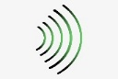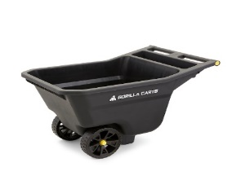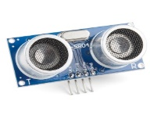

We designed the car by using 3 wheels car kit. And put an ultrasonic sensor in the front and 2 infrared sensors at the left and right of ultrasonic to detect is there any object in front of the car. When our hand or any object is placed in front of the “car”, the car will follow it and stop in 15-25cm gap. So, it will keep 15-25cm distance so that it won’t bump the object in front of it.

For instance, the car will turn left if user hand goes left, will go right if hand go right, will follow the hand when the hand goes further away.

IR (infrared) sensor is used to increase the sensitivity of the object tracing and to tackle the problem of the incapability of ultrasonic sensor to detect the object on the side. The idea is by installing IR sensor on both right and left side of the ultrasonic sensor and catch the signal from each IR sensor and ultrasonic sensor.

The control of the IR sensor is simple. The sensor will send a 1 (TRUE) signal if there is nothing detected by the sensor and 0 (FALSE) otherwise. For readability, we invert the value so the car will move if there is an object in front and depends on others sensor signal otherwise.

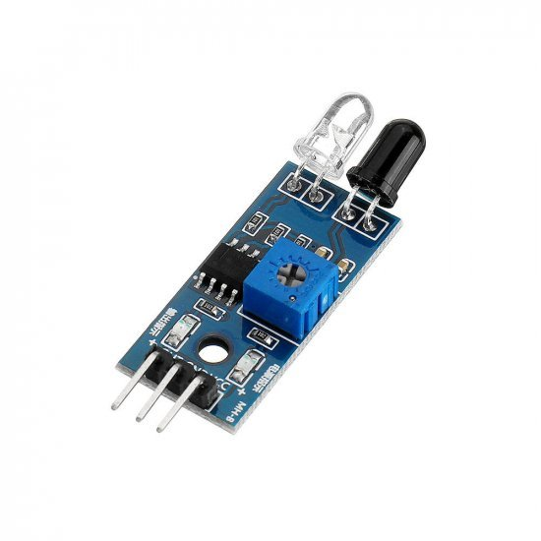

To adjust the strength and weak of the IR sensor, we need to adjust the potentiometer on the IR sensor module. The range can be adjusted up to around **25 cm**. the sensor itself can detect object around it with up to around **35o**.

For the ultrasonic sensor, we need to calculate the length of signal that bounce to the receiver (echo) to calculate the distance between the object in front of it.

Because ½ is the same as shift right by one bit. Therefore, we just simply shift it by one bit. And then we need to multiply it by 0.034cm/s since we are using cm to measure the distance. To multiply it, we shift distance register (pulse length) by 5 bits. the reason is because 1/25 = 0.031 which is close to 0.034. And it doesn’t matter that if the calculation is not really accurate since we just need to stop the car in certain distance. And the code as like below (shifting right by 1 + 5 = shifting right by 6 bit).



The car will turn left if left IR sensor and the ultrasonic sensor detect the object, while if right IR sensor and the ultrasonic sensor detect the object, the car will turn right. If there is an object in front and still not too close, the car will go forward.

* **Mode 2 (Speech Command)**

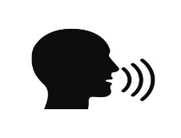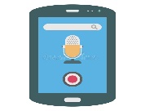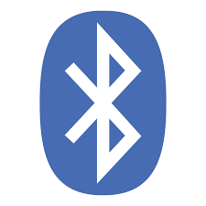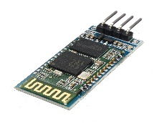

In this mode, the car is controlled by utilizing an android app which will then send the speech signal to Bluetooth module. If the word “one” is spoken, the car will go to **mode 1,** else if the word “two is spoken, the car will go to **mode 2.** Or if the user doesn’t wish to use speech recognition to change the mode, they can always use the switch to change between modes, where switch0 id to go to **mode 1** and switch1 is to go to **mode 2.**

When the car encounter obstacles when it moves forward or backward, an ‘alarm’ like sound will be played and the car will stop from moving, in addition, the LED lights on FPGA board will blink and the seven segment will also blink with a blank pattern until the obstacles has been removed.

The speaker control is designed with 4 separate modules; player_control, note_gen, speaker_control, and the sound (music) module.

* Player_control module is used to generate the beating count for the sound
* Note_gen module is used to generate the desired music note
* Sound module is the list of note to be played
* Speaker_control module Is to control the output of the sound through speaker or other music hardware like headset.

In this project, the sound note list consist of the combination of high-pitch b note and silence sound in alternative order.

**Materials :**

* HC – 06 Bluetooth module x1
* HC – SR04 Ultrasonic sensor x1
* Flying fish IR (infrared) sensor x3
* FPGA Board x1
* L298N Motor module x1
* 3 Wheeled car kit x1
* Battery x1
* Dupont wires

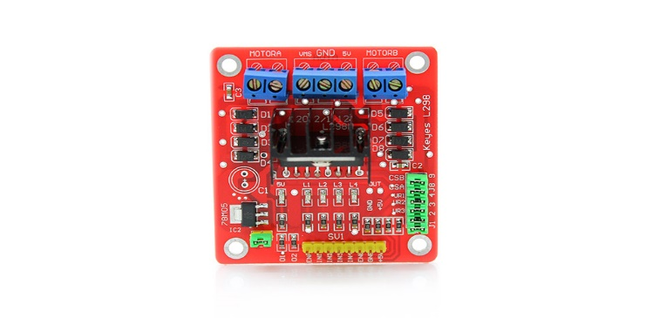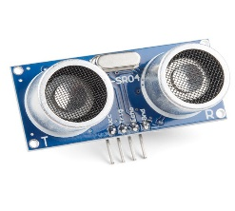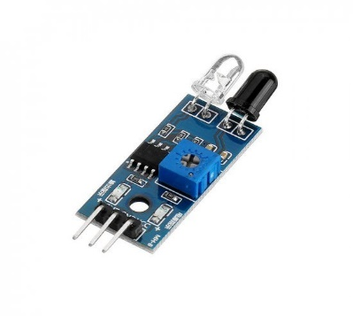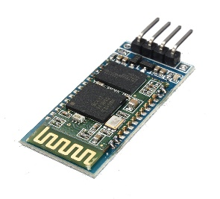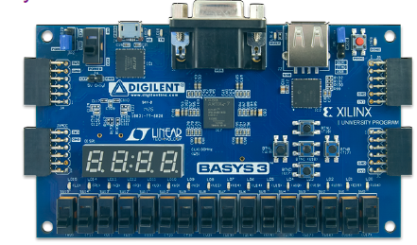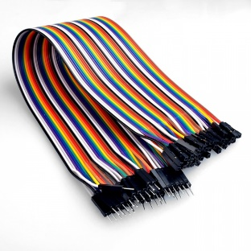

Group Member Works Distribution

**黃志偉**

* Top module
* Material purchase
* IR sensor control
* Speaker control
* Timing Control

**許媄香**

* Top module
* Material purchase
* Ultrasonic control
* Motor control
* Bluetooth control
* Design

1. **學到的東西與遇到的困難**

Asd

1. **想對老師或助教說的話**

Awfd